Name: ____________________________ Date: ____
Honors English 12 Period: __
British Romanticism
Ah, romance.
Bouquets of roses, Valentine's Day treats, smooching over a candlelight dinner…

Okay, did you get that out of your system? Good. Because for the rest of this unit, you're going to throw all your associations with romance out the window and buckle down on what Romanticism is really about.

That's' right: the Romantics were a group of poets writing and publishing in the late 18th and early 19th century in Britain—and their poetry didn't start with "roses are red."

Why do we call them "Romantics," then, if these guys weren't, you know, romantic? Well, we use the term "romantic" because they were really into emotions: happiness, sadness, joy, loneliness…you know the drill. They got especially emotional about Nature (capital N!)—a lot of their emotions were inspired by natural goodies…as opposed to a really sexy shade of lipstick. They were coming off the heels of the Enlightenment, when folks decided to value reason over emotion, and they were not cool with it.

What else set them apart? They were unconventional. Since they believed in being true to their emotions, they refused to be constrained by social or literary or political conventions—conventions of any kind, for that matter. They were rebellious, they were individualistic…and their writing reflected it. They were all about poetic experimentation, which means that the most important Romantic writers revolutionized the way poetry was written.

Nitty gritty aside, some of the greatest poets in the English language came out of this movement. And once you learn their names (hint: Keats, Byron, Shelley, oh my!), you'll be invited to more dinner parties than you can fit on your calendar.

Why Should I Care?
We can't escape it nowadays. Television, Internet, ads, movies: everyone is telling us what we should be doing with our lives, what we should want, what we should look like, and what we should feel. Of course we should want to be rich. Of course we should want to be skinny. Of course we should want to get married and have kids and live in the suburbs.

It gets tiring living in a culture that's always putting pressure on us to conform, to be like other people, and to want what everyone else wants. And we begin to question ourselves: are we weird for not wanting to take that job? For not wanting to dress like that? For not wanting to behave in that way?

If you've ever had those questions, you've got more in common with the Romantics than you might have thought possible. Their big message to us readers is you do you.

And they did pretty well for themselves, didn't they? So why not follow their lead? Not that I’d want you to conform…

The Top 10 List

The Must-Knows of Romanticism

(1) French Revolution
The French masses got sick of Louis XVI and his wife Marie-Antoinette living the high life in Versailles…so they cut of their heads. The French Revolution was the start of a whole new revolution in politics and society. Don't think the Romantics weren't influenced by all this jazz.

(2) Industrial Revolution
The rise of the machines! No, not the Terminator. (Although, to be fair, we weren't alive then, so maybe he was around…) When mechanized manufacturing processes transformed work and production, factories started popping up everywhere and people left the country for the city to work in them. Note to self: there's less nature in the city.

(3) Nature
Trees, rivers, birds, bees…the Romantics lapped it up. These guys were crunchies before crunchies came along. According to the Romantics, we simply could not be happy or whole without a connection to nature. Lots of people like to refer to the Romantics' nature as Nature with a capital N because it was more than just the grass and the oceans—it was the whole concept.

(4) Heroism
Do we really need to explain this one? The Romantics were really into characters who exemplified bravery, courage, and other hero-like qualities. They wrote about and cherished characters who went against the grain, who were larger than life, whose actions were bold and spectacular. Think Don Juan, Frankenstein's monster, or Prometheus, all of whom were heroes (or, in some cases, anti-heroes) that the Romantics made famous.

(5) Emotion
We can't help the way we feel, and the Romantics would say that we shouldn't try to. Let's just let ourselves be washed over by emotions. That's what being human is all about, isn't it? And if we're super clever, we'll write poems about our feelings. That's what the Romantics did, anyway.

(6) Rebellion
The Romantics didn't like conventions. They rebelled against literary conventions, they rebelled against political conventions, and they rebelled against social conventions. They believed that we should first and foremost be true to ourselves, which means not going along with the herd.

(7) Ruins and Relics of the Ancient Past
The Romantics really dug dug-up stuff: vases from ancient Greece, old statues, and ruined buildings. They used all this junk—er, treasure—as a way to reflect on time, and the passing of time.

(8) Sense and Sensuality
Sounds, sights, smells, and textures are a hallmark of Romantic literature. These writers believed that if we just sit there (preferably under a tree) and look around, listen, and sniff the air, we'll learn a lot. Our body is a learning instrument that's just as important as our mind or "intellect." Why let it go to waste?

(9) Sublime
This one's tricky and most folks can't quite agree on what it means, but generally, we experience the sublime when we're out in nature and we're totally overwhelmed by it. Think of the feeling you might get when you saw Niagara Falls, the Grand Canyon, or Mount Everest for the first (or thousandth) time. This is nature at its biggest and baddest, and when we see it, we feel a whole mess of very powerful emotions including both terror and joy.

(10) Experimentation with Poetic Form
The Romantics weren't just innovative in terms of content; they also loved to play with style. They broke with the literary conventions that they'd inherited from their predecessors, and in turn, changed the way that poetry was written. We told you these dudes (and dudettes) were rebels.

Shmoop Editorial Team. "Romanticism." Shmoop. Shmoop University, Inc., 11 Nov. 2008. Web. 5 Jan. 2016.

Your Assignment
Create a visual representation of the Romantic Period based on the information you find most important from this article.

You may also use pages 696-708 in your textbook. You may also use your phones.

You have all of in the information that you need at your fingertips – your visual representation of the Romantic Period will be due at the end of the period. I have left paper and markers for you to use.

Create a MIND MAP that proves to me that you understand the Romantics!

Example:
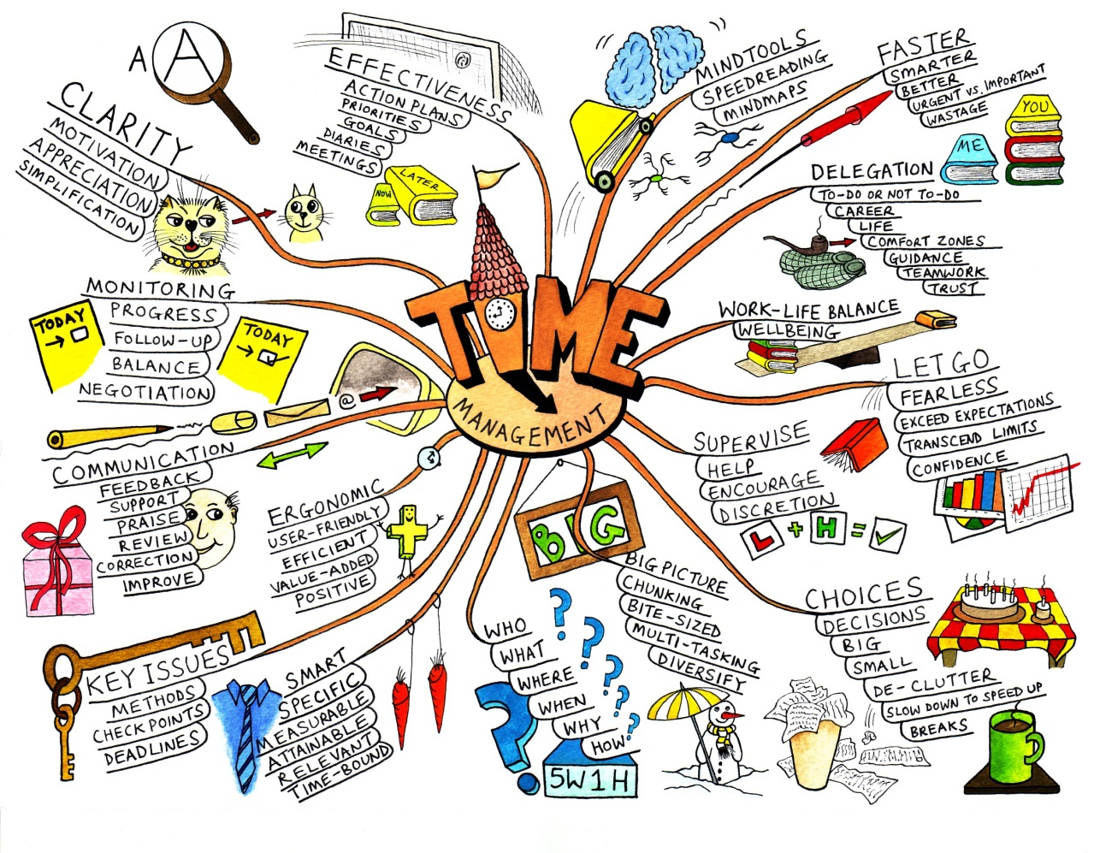

When you’re done, study your literary terms, get started on your poetry project, OR study your rootwords
(Quizlets available at www.missaubrey.weebly.com).

