Name: ____________________________ Date: ____
Honors English 12 Period: __

John Keats
(1795 – 1821)

What John Keats did... and why you should care
Pity the short, tragic life of poet John Keats. Abandoned, orphaned and impoverished as a child, he was pulled from school and forced into a medical career he didn't want by an unscrupulous guardian. He found the courage to pursue a literary career at the age of 21, but by then his life was already approaching its end. He suffered from bad reviews, then depression, and then tuberculosis, the last of which proved deadly. He died in 1821 at the age of twenty-five, leaving behind a broken-hearted fiancée, a handful of poems and a legacy as one of the great poets of the Romantic age.
Critics were so hard on Keats during his lifetime that his friends believed that he died from the stress of his negative reviews. (An autopsy of his tuberculosis-ravaged lungs debunked that theory.) Yet Keats' reputation has proved to be more enduring than the names of any of his critics. Today, Keats' lines are part of our collective consciousness. "A thing of beauty is a joy forever,"¹ "Beauty is truth, truth beauty" - these lines and more come to us courtesy of John Keats. He never achieved old age, but he arrived at immortality.
In the final, painful months of his life, unable to write and separated from the woman he loved, Keats lamented that he was living a "posthumous existence"- that is, he felt dead already. Ironically, Keats' posthumous life has turned out to be longer and more illustrious than the one he had on earth. Though he'd published just a handful of poems by the time he died in 1821 at the age of 25, his work establishes him as a natural talent and one of the stars of English Romantic literature. We can only imagine the heights his talent would have reached had he lived.
Keats' dramatic life seems like the subject of a Romantic poem, which in fact it was. (Percy Bysshe Shelley, who died just one year later at the age of 29, composed the elegy Adonais upon his friend's death.) He was abandoned, orphaned, mistreated by a wily guardian. Just when it seemed like Keats' life was coming together - his poetry was getting decent reviews, he was set to marry the woman he loved - he was taken down by tuberculosis, the disease that killed his mother and brother. Keats was well aware of the tragic quality of his life - in fact, he could be a little self-pitying - but there's no denying that his own painful experiences contributed to the poignancy of his poems, and to his unparalleled powers of perception.
- Keats was no wimp. He was known for his ability to rule in schoolyard fights. As one student recalled, his classmates expected that he "would become great - but rather in some military capacity than in literature."
- One of Keats' duties as a medical student in the era before anesthesia was to physically restrain patients on the operating table during surgeries.
- The doctor who autopsied Keats said the poet suffered from the worst case of tuberculosis he had ever seen. He couldn't believe Keats had lived as long as he did.
- In keeping with his requests, Keats was buried with Fanny Brawne's unopened letters, a lock of her hair and a purse made by his sister.
- For years after Keats' death, his fans (including Byron and Shelley) believed that his fatal lung hemorrhage was caused by the stress of his negative reviews.
- Fanny Brawne wore the gold engagement ring John Keats gave her until her death in 1865.
- Percy Bysshe Shelley drowned in 1822, and when his body washed ashore, it was identified by the copy of Keats' Lamia that he carried in his pocket.

John Keats practically defines the term "Romantic." Not just in the literary sense, referring to a group of English writers working in the first half of the 19th century, but also in the more modern sense of a guy whose life is filled with drama and passion. He was raised in a middle-class family, unlike many of the more aristocratic Romantics such as William Wordsworth, and critics mocked him as a small town boy and an upstart. His first poems were either made fun of or ignored, and he never succeeded in becoming famous or respected during his short life. Keats died of tuberculosis at the age of 25, shortly after the publication of his last book of poems, which included the "Ode on a Grecian Urn."
Based on the quality of these poems, written at so young an age, it’s awe-inspiring to think of what kind of writer Keats could have become had he survived as long as his peers. It’s not too much of a stretch to imagine that he could have been another Shakespeare. But his early death has only increased the myth and aura of the Romantic Keats.
Keats wrote five odes, and all of them are shockingly good. These are the kinds of poems that literary critics die for, and that send later writers into bouts of envy. Of the five odes, "Grecian Urn," with its immortal and mysterious final lines, is the most well-known. The "ode" is an Ancient Greek form of poetry that is marked by its seriousness and technical difficulty. They are usually very thoughtful works that try to praise and elevate their subject. Keats’s odes are considered the best in the English language, and they are certainly the most famous. Anyone who has even a passing interest in poetry should read them, and re-read them. To a great extent, they have defined what modern lyric poetry is.
"Ode on a Grecian Urn" was written in 1819, the year in which Keats contracted tuberculosis. He told his friends that he felt like a living ghost, and it’s not surprising that the speaker of the poem should be so obsessed with the idea of immortality.
The poem consists of a person talking to a kind of fancy Greek pot known as an "urn" that was made of marble. Keats would have been able to see many urns from Ancient Greece at the British Museum, the world's biggest archeological treasure-trove. (The northern Europeans plundered the Greeks' ancient artifacts, and some might joke that now the Greeks are taking revenge by blowing up the European economy…) Urns are known not only for their sleek, beautiful shape but also for the quality of the pictures that were often painted on their sides. Most of the poem centers on the story told in the images carved on the side of one particular urn. But this isn’t some mellow reflection on a pot: it’s a wild rollercoaster of a poem covering BIG subjects like sex, love, nature, and death.

“Ode on a Grecian Urn”

WHY SHOULD I CARE?
Back in the 19th century, the first readers of John Keats’s poetry were like, "Keats, man, this stinks." They might also have thrown in some slander about his middle-class origins. Nowadays, people are more likely to have the opposite reaction and say, "Wow, this is the most amazing poem I’ve ever read!"
How could a single work provoke both disdain and ecstatic praise? We need a modern equivalent to understand the phenomenon. So, we’re going to compare the publication of Keats’s first book of poems, which included this ode, to the time when Bob Dylan started playing "Like a Rolling Stone"on an electric guitar. If you don’t know the back-story, Dylan started his career playing folk music and protest songs on an acoustic guitar at small festivals. Sometime around the middle of the 1960s, he began writing songs for a full band and electric guitar, which many of his fans considered high treason. He’d start out his concerts playing his old stuff, the quiet folk songs, and halfway through he’d plug in his electric guitar, turn the volume way up, and basically blow people’s ears off. Subtle? No. Historic? Definitely.
The Romantic poets made a similar fuss back in the 19th century. Before they came along, most English poets were writing quiet, polite poems with simple rhyme schemes about old-fashioned subjects like Ancient Greece and Rome. Then the first Romantic poets William Wordsworth and Samuel Taylor Coleridge came along and published poems in everyday language about dramatic subjects like shipwrecks and the plight of rural farmers. Returning to our comparison, this was like the invention of rhythm and blues. But it didn’t stop there.
The second generation of Romantics, including Keats, came along next, and they were like, "Guys, this is really good, but it’s not radical enough. We need to turn the volume way up." So Keats wrote poems like this ode, which takes a polite subject – a study of a Greek pot – and turns it into a screeching, over-the-top celebration of music, sex, and youth. The form is incredibly dense and complicated, and the language practically chokes you with complex metaphors, bizarre repetitions, and tortured emotion. Even the first generation of Romantics had to plug its collective ears and say, "For heaven’s sake, turn it down!" But it was too late. After the "Ode on a Grecian Urn," poetry was never the same, just like rock and roll was never the same after "Like a Rolling Stone." Pandora’s Box had been opened. Unlike Dylan, however, Keats didn’t live to see his poems become famous and critically acclaimed. He died when most people still thought he was a crummy poet.

Shmoop Editorial Team. "Ode on a Grecian Urn." Shmoop. Shmoop University, Inc., 11 Nov. 2008. Web. 26 Dec. 2015.

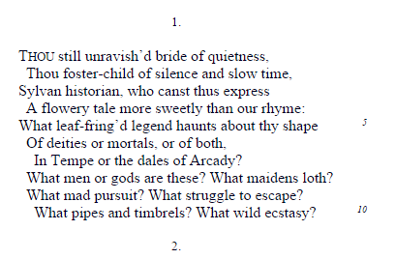
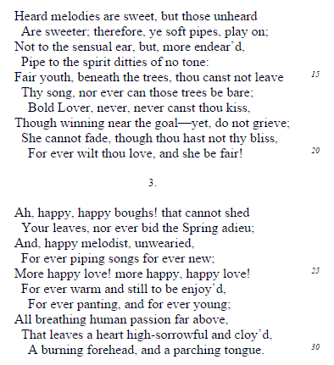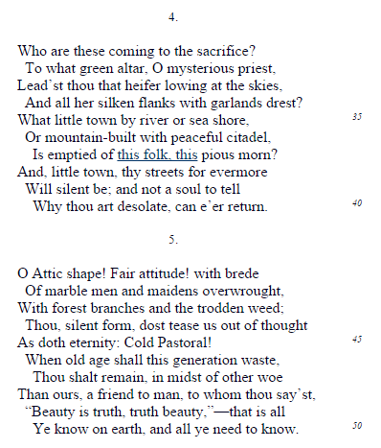
Ode on a Grecian Urn

Getting at meaning

- To what “unheard melodies” does the second stanza refer? Why are they “sweeter” than the heard ones?

- Similarly, the third stanza refers to warmth and passion of two kinds, or on two levels. what are they? What advantages do the lovers on the urn enjoy? What are the limitations of art as represented by the urn?

- The urn has caught the warmth and motion of a moment held forever in suspension, and in the fourth stanza the reader is drawn even further into the “eternal Present”. what part of the scene is not even pictured on the urn and must be imagined? In the last line of the fourth stanza, who or what is “Desolate”?”

Developing Skills in Reading Literature
- Ode. The ode, an elaborate kind of lyric poem, deals with a serious theme in language that is dignified as well as enthusiastic and exalted. in what ways does this poem exemplify the characteristics of an ode?

- Diction. Poets can make use of ambiguity , choosing words with various possible meanings. consider still in line 1. in what two senses might this word be understood? how might each be appropriate to the poem’s meaning? Can you find any other examples of this?

Bring on the tough stuff - there’s not just one right answer.
- Have you ever been happy enough that you felt you could live in that moment forever? If not, did this poem convince you that such moments are possible?
- What’s the deal with the speaker? He’s all over the place. He seems to go from curious to nostalgic to lustful to frustrated. If you had to write his fictional life story, what would it say?
- Why do you think the first critics of Keats’s poetry hated it so much?
- How would you describe the overall tone of the poem? Is it joyful or sad?
- Is the speaker able to identify with the Ancient Greeks depicted on the urn, or is he merely excited by the "mystery" of their culture and its foreignness. Do you feel like you can identify with life on the urn?

