Name: __________________________________________ Date: ________
Honors English 12 Period: _______
The Canterbury Tales
Geoffrey Chaucer
Please Do Now:
Identify journeys you have undertaken with other people. Describe ways people often pass the time when they are traveling.

Author Study: Geoffrey Chaucer
and The Medieval Period (1066-1485)
Jigsaw Activity
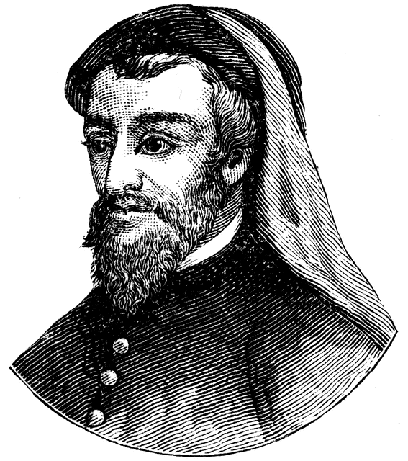
Directions: Using the attached pages, take notes on your assigned sections. Remember to only jot down what you think is the most important information (2-3 important ideas). You will work with your section group before you report back the information to your home group.

- England’s First Great Writer / Befriended by Royals (p.107 -108)
- Early Inspirations / Turbulent Times (p.108-109)

- Fruitful Years / Literary Contributions (p. 109-110)

- Uncommon Honor / Chaucer’s London/ The Shrine of Canterbury (p.110)
- The Medieval Period (1066-1485) p. 22-24

- Development of the English Language/ Literary History (p.23)

- The Decline of Feudalism/The Hundred Year’s War (p. 24-26)
- Literary History (p.25)/Development of the English Language (p.26)/Literary History (p.26)

Background Lecture Notes:

Thomas a Becket

Canterbury Cathedral

The Crusades

Medieval Social Classes

The Black Plague

Pilgrimages

